

Event Series Title:
Generation of Innovation

PROPOSAL TO:
Canadian Society of Senior Engineers

Inspiration | Innovation | Mentorship


MISSION
Cultivate the diffusion of mentorship and innovation.

Collaboration
- Active members of UVic clubs
- UVic faculty
- Guests from the STEM and business communities

Scope
The CSSE – Victoria Chapter - hosts discussions that present insightful ideas to the young bright minds of the future. These events bring together two ends of the engineering spectrum, young adults and senior professionals. The UVic Clubs are encouraged to collaborate with other clubs, and faculty to promote the club projects.

PROTOCOL
Format: 3rd Wednesday of Month @ 1600-1730 hrs.
- Socializing, snacks, coffee (15min)
- Guest speaker (45 min – 1hr)
- Networking drills and conversation
Facility
- Room (capacity: 100)
- Projector and sound
- Snacks from Cobbs Bread
- Coffee from Starbucks

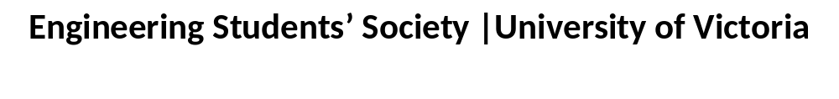

COMMITTEE AND ROLE
External Coordinator: Robin Black - CSSE
- Collaborate CSSE involvement

Internal Coordinator: Sally Sun & Christina Saimoto - ESS
- Room bookings and food/drink sponsorship
- Conduct networking drills

Club Coordinator: Matthew McCann - UVic Robotics
- Coordinate guest speaker, event, and promotions.

CLUBS
AERO AUVic Experimental Radio Group
BioDev Canoe Team Engineering without Borders
- ECOSat Formula Hybrid Formula Motorsport
IEEE MakerSpace Learning Through Diversity (LTD)
Robotics Rocketry Software Dev. and Machine Learning

CLOSING COMMENTS
During the EIC/CSSE Spring Planning Meeting on 18May2016, I, Matthew McCann, was presented with the question of how increase EIC/CSSE involvement with the Engineering Students’ Society at UVic. The structure of these events provides an informative environment where the CSSE may host presentations that invoke innovation, inspiration, and mentorship.

Engineering Students’ Society | University of Victoria

